504 (IWT)
UNIT 01
Q1 ; Define the concept of the World Wide Web (WWW) and differentiate it from the Internet. How are they interconnected?
ANS ; World Wide Web (WWW) kya hai?
World Wide Web (WWW) ek information system hai jisme:
- Web pages (HTML pages)
- Websites
- Images, videos, text, links
hote hain.
👉 In sab ko hum web browser (jaise Chrome, Firefox) ki help se access karte hain.
📌 Example:
- Google.com
- YouTube.com
- Wikipedia.org
👉 Ye sab WWW ka part hain.

🔹 Internet kya hai?
Internet ek global network of networks hai jo:
- Millions of computers
- Servers
- Mobile devices
ko duniya bhar me connect karta hai.
👉 Internet ek road system jaisa hai jo data ko ek jagah se dusri jagah pahunchata hai.
📌 Internet ke through hum:
- Email bhejte hain
- Video call karte hain
- File transfer karte hain
- Web access karte hain

🔸 WWW aur Internet me Difference
Internet | World Wide Web (WWW)
Infrastructure / Network | Information System
Hardware + Software ka network | Web pages ka collection
Internet bina WWW ke exist kar sakta hai | WWW Internet ke bina kaam nahi kar sakta
Email, FTP, WWW sab support karta hai | Sirf websites & web pages

🔗 WWW aur Internet ka Connection (Interconnection)
👉 WWW Internet ka ek part hai.
- Internet = Base system (foundation)
- WWW = Service jo Internet par chalti hai
📌 Jab tum browser me website open karte ho:
- Request Internet ke through jati hai 🌐
- Server se data aata hai
- WWW ke rules (HTTP, HTML) follow hote hain
👉 Isliye:
WWW Internet ka use karta hai data transfer ke liye

🌟 Short & Powerful Line (Exam ke liye)
Internet ek global network hai jabki World Wide Web usi Internet par chalne wali web-based information system hai.

Q:2 Explain the HTTP protocol in detail, highlighting the elements involved in a request and response cycle.
Ans : HTTP kya hai?
HTTP (HyperText Transfer Protocol) ek communication protocol hai jo client (browser) aur server ke beech data transfer karne ke liye use hota hai.
👉 Jab bhi tum browser me koi website open karte ho, HTTP help karta hai:
- Request bhejne me
- Response lene me
📌 Example:
Tumne browser me likha → www.google.com
Browser HTTP request bhejta hai, server HTTP response deta hai.

🔄 HTTP Request–Response Cycle (Flow)
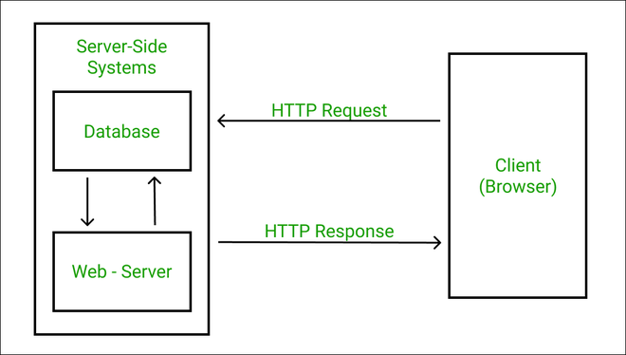
Steps:
- Client (browser) request bhejta hai
- Server request process karta hai
- Server response bhejta hai
- Browser data show karta hai

🔸 HTTP Request ke Elements
HTTP Request mainly 4 parts se milkar banti hai:
1️⃣ Request Line
Isme hota hai:
Method URL HTTP Version
📌 Example:
GET /index.html HTTP/1.1
👉 Common HTTP Methods:
- GET → Data mangna
- POST → Data bhejna
- PUT → Data update
- DELETE → Data delete

2️⃣ Headers
Headers extra information dete hain server ko.
📌 Examples:
- Host
- User-Agent
- Accept
- Content-Type
👉 Batata hai:
- Browser ka type
- Data format
- Language, etc.

3️⃣ Blank Line
Headers aur body ko separate karti hai.

4️⃣ Request Body (Optional)
Sirf POST/PUT me hoti hai.
📌 Example:
- Login form ka data
- Signup details

🔹 HTTP Response ke Elements
Server jab reply karta hai, to usme bhi 4 parts hote hain:
1️⃣ Status Line
HTTP Version Status Code Message
📌 Example:
HTTP/1.1 200 OK
👉 Common Status Codes:
- 200 OK → Success
- 404 Not Found → Page nahi mila
- 500 Internal Server Error → Server problem
- 301 Moved Permanently → Page shift ho gaya

2️⃣ Response Headers
Ye batate hain:
- Server type
- Content length
- Content type
📌 Example:
- Content-Type: text/html
- Date
- Server

3️⃣ Blank Line
Headers aur body ke beech gap.

4️⃣ Response Body
Actual data jo browser ko chahiye:
- HTML page
- Image
- JSON data

🔐 HTTP ki Important Characteristics
- Stateless Protocol
👉 Har request independent hoti hai (server ko purani request yaad nahi rehti)
- Client–Server Model
👉 Client request karta hai, server response deta hai
- Text-based Protocol
👉 Readable format me hota hai

🔒 HTTP vs HTTPS (Short Note)
- HTTP → Data encrypted nahi hota
- HTTPS → Secure + encrypted data transfer 🔐

Q:3 : What are the primary roles of web browsers and web servers? How do they interact to facilitate the browsing experience?
Ans : Web Browser ka Primary Role (Kya kaam karta hai?)
Web Browser ek client software hota hai jo user aur internet ke beech bridge ka kaam karta hai.
👉 Browser ka main kaam:
- User se URL lena (jaise: google.com)
- Web server ko request bhejna
- Server se aane wale data ko samajhna
- Web page ko screen par properly show karna
📌 Examples of browsers:
- Chrome
- Firefox
- Edge
- Safari
👉 Browser HTML, CSS, JavaScript ko render karke visual web page banata hai.

🔹 Web Server ka Primary Role (Kya kaam karta hai?)
Web Server ek system (hardware + software) hota hai jo:
- Websites ko store karta hai
- Browser se aane wali request ko process karta hai
- Correct response wapas bhejta hai
👉 Web server ka kaam:
- Request receive karna
- File ya data dhundhna
- Response bhejna (HTML, image, JSON, etc.)
📌 Examples:
- Apache
- Nginx
- IIS

Browser aur Server ka Interaction (Browsing Experience kaise hota hai?)
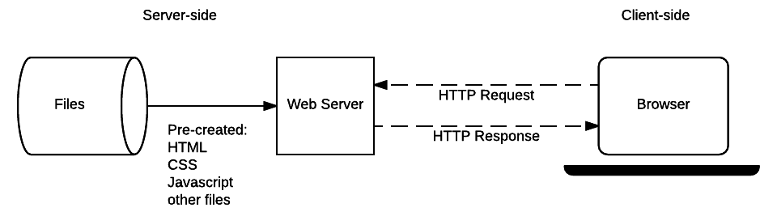

🔁 Step-by-Step Interaction:
1️⃣ User browser me URL type karta hai
2️⃣ Browser HTTP request bhejta hai web server ko
3️⃣ Web server request ko process karta hai
4️⃣ Server HTTP response bhejta hai (page/data)
5️⃣ Browser response ko render karta hai
6️⃣ User ko web page dikh jata hai 🎉
👉 Ye pura process milliseconds me hota hai.

🔸 Browser vs Web Server (Difference Table)
Web Browser | Web Server
Client side hota hai | Server side hota hai
User ke system par run karta hai | Remote machine par run karta hai
Request send karta hai | Request receive karta hai
Data ko display karta hai | Data ko store & serve karta hai

Q 4. Discuss the evolution from Web 1.0 to Web 2.0, emphasizing the key features and functionalities introduced in Web 2.0.
Ans : Web 1.0 kya tha? (Read-Only Web)
Web 1.0 internet ka initial phase tha (1990s ke around).
👉 Is stage par:
- Websites static hoti thi
- User sirf content read kar sakta tha
- Interaction almost zero tha
📌 Example:
- Simple HTML pages
- Company information websites
- News pages (sirf padhna, response nahi)
✨ Features of Web 1.0:
- Read-only content
- Static web pages
- No user interaction
- One-way communication
- Limited graphics & design

🔄 Need for Change
Time ke saath users sirf padhna nahi, balki:
- Comment karna
- Like, share karna
- Content create karna
chahne lage.
👉 Yahin se Web 2.0 ka concept aaya 🚀

🔹 Web 2.0 kya hai? (Read-Write Web)
Web 2.0 ek interactive, dynamic aur user-centric web hai.
👉 Yahan users:
- Content create kar sakte hain
- Interact kar sakte hain
- Real-time response le sakte hain
✨ Key Features & Functionalities of Web 2.0
1️⃣ User Interaction
- Like, comment, share
- Two-way communication
2️⃣ Dynamic Content
- Page reload ke bina data update hota hai
- JavaScript, AJAX ka use
3️⃣ User-Generated Content
- Blogs
- Social media posts
- Reviews & ratings
4️⃣ Social Networking
- Community building
- Collaboration & sharing
5️⃣ Rich User Experience
- Better UI/UX
- Animations, multimedia support
6️⃣ Web Applications
- Online tools & apps
- Real-time services

🔸 Web 1.0 vs Web 2.0 (Difference Table)
Web 1.0 | Web 2.0
Read-only | Read & Write
Static pages | Dynamic pages
No interaction | High interaction
Owner-controlled content | User-generated content
Simple UI | Rich & interactive UI

Q 4 : Outline the fundamental principles of effective web design. How do these principles contribute to an engaging user experience?
Ans : Effective web design ka matlab hai:
👉 Website simple, usable, attractive aur user-friendly ho
👉 User ko bina confusion ke jo chahiye, wo jaldi mil jaye
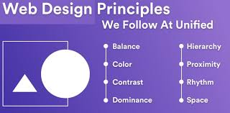
1️⃣ Simplicity
- Design clean aur simple hona chahiye
- Extra colors, fonts, elements avoid karo
👉 Impact on UX:
User confuse nahi hota, focus content par rehta hai 😊

2️⃣ Consistency
- Same color scheme
- Same font style
- Same layout pattern
👉 Impact on UX:
User ko site use karna easy lagta hai, familiarity build hoti hai 👍

3️⃣ Clear Navigation
- Menu simple ho
- Important pages easily accessible ho
👉 Impact on UX:
User bina lost hue website explore kar pata hai 🚶‍♂️➡️🎯

4️⃣ Responsive Design
- Website mobile, tablet, laptop sab me achhi dikhe
- Screen size ke hisaab se adjust ho
👉 Impact on UX:
User kisi bhi device se comfortable experience leta hai 📱💻

5️⃣ Visual Hierarchy
- Headings prominent ho
- Important buttons highlight ho
👉 Impact on UX:
User easily samajh pata hai kya important hai 👀✨

6️⃣ Fast Loading Speed
- Images optimized ho
- Unnecessary scripts avoid ho
👉 Impact on UX:
Slow website = frustrated user ❌
Fast website = happy user 😄

7️⃣ Accessibility
- Readable fonts
- Proper contrast
- Keyboard & screen-reader support
👉 Impact on UX:
Har type ka user website use kar sakta hai ♿🌍

8️⃣ Content Readability
- Short paragraphs
- Proper spacing
- Simple language
👉 Impact on UX:
User content enjoy karta hai, skip nahi karta 📖✔️

🔗 How These Principles Create an Engaging User Experience
- User ko control ka feel aata hai
- Website use karna easy & enjoyable hota hai
- User zyada time website par spend karta hai
- Chances badhte hain:
  - Return visitors ke
  - Conversions ke
  - Trust ke

✍️ Exam-Oriented Conclusion (7 Marks Ready)
Effective web design principles like simplicity, consistency, clear navigation, responsiveness, fast loading speed, and accessibility help create a user-friendly interface. These principles improve usability, reduce confusion, and enhance overall user engagement and satisfaction.

Q 6: Analyze the significant web design issues related to browsers, bandwidth, cache, and display resolution. How do these impact website usability?
Ans : 🔹 1. Browser Compatibility Issues
Different users different web browsers use karte hain (Chrome, Firefox, Edge, Safari).
❗ Problem:
- Har browser CSS & JavaScript ko thoda different tarike se interpret karta hai
- Jo website Chrome me perfect dikhti hai, wo Firefox me break ho sakti hai
🎯 Impact on Usability:
- Layout distort ho sakta hai
- Buttons ya features kaam nahi karte
- User ka trust kam ho jata hai ❌
✅ Solution:
- Cross-browser testing
- Standard HTML, CSS use karna

🔹 2. Bandwidth Issues
Bandwidth ka matlab hai internet speed ya data transfer capacity.
❗ Problem:
- Heavy images
- Large videos
- Unoptimized scripts
Low bandwidth users ke liye site slow ho jaati hai.
🎯 Impact on Usability:
- Page late load hota hai
- User frustrate ho kar website chhod deta hai 😕
✅ Solution:
- Image compression
- Lazy loading
- Minified CSS & JS

🔹 3. Cache Issues
Cache browser ka temporary storage hota hai jisme website data save rehta hai.
❗ Problem:
- Old cached files load ho jaate hain
- Updated content user ko dikhta hi nahi
🎯 Impact on Usability:
- User ko outdated information milti hai
- Bugs fix hone ke baad bhi problem dikhti hai
✅ Solution:
- Proper cache-control headers
- Versioning (style.css?v=2)

🔹 4. Display Resolution Issues
Users alag-alag screen sizes use karte hain:
- Mobile 📱
- Tablet
- Laptop 💻
- Desktop 🖥️
❗ Problem:
- Fixed-width design
- Text chhota ya bahut bada dikhta hai
- Horizontal scrolling aata hai
🎯 Impact on Usability:
- Poor readability
- Navigation difficult ho jaata hai
- Mobile users website chhod dete hain
✅ Solution:
- Responsive design
- Flexible layouts (CSS media queries)

🔄 Overall Impact on Website Usability
Agar in issues ko ignore kiya gaya:
- User experience kharab ho jaata hai
- Website slow, broken, ya unreadable lagti hai
- Bounce rate badh jaata hai ❌
Agar inhe properly handle kiya:
- Website fast, smooth & accessible banti hai
- User satisfied rehta hai 😊
- Engagement & trust badhta hai 🚀

✍️ Exam-Oriented Conclusion (7 Marks Style)
Web design issues related to browser compatibility, bandwidth limitations, cache handling, and display resolution significantly affect website usability. Poor handling of these issues can lead to slow performance, broken layouts, outdated content, and poor user experience, whereas optimized design improves accessibility, performance, and user satisfaction.

Q7 : Describe the concept of "look and feel" in web design. How does it influence user perception and engagement on a website?
Ans : 🔹 Look and Feel kya hota hai?
Look and Feel web design ka wo overall visual aur interactive experience hota hai jo user website use karte waqt feel karta hai.
👉 Isme include hota hai:
- Colors 🎨
- Fonts ✍️
- Layout 📐
- Buttons & icons
- Animations
- Overall style & mood
👉 Simple words me:
Website dikhti kaisi hai (look) aur use karte waqt kaisa mehsoos hota hai (feel).

🔑 Elements that Define Look and Feel
1️⃣ Color Scheme
- Colors emotions trigger karte hain
- Professional, energetic, calm — sab colors se reflect hota hai
🎯 Impact:
Trust aur brand identity build hoti hai

2️⃣ Typography
- Font style & size
- Text readability
🎯 Impact:
User content easily consume karta hai 📖

3️⃣ Layout & Spacing
- Content ka arrangement
- White space ka use
🎯 Impact:
Clean layout = less confusion = better focus 👀

4️⃣ Consistency
- Same design pattern har page par
🎯 Impact:
User ko website predictable aur easy lagti hai 👍

5️⃣ Interactivity & Feedback
- Hover effects
- Button animations
- Loading indicators
🎯 Impact:
User ko response milta hai, engagement badhta hai 🎯

🔗 How Look and Feel Influences User Perception
🧠 User ke dimaag par impact:
- Professional design → Trust
- Poor design → Doubt & exit
- Attractive design → Positive first impression
👉 User website ke quality ko design ke basis par judge karta hai.

🚀 How It Affects User Engagement
- User zyada time website par spend karta hai
- Navigation easy lagta hai
- Actions (signup, click, purchase) increase hote hain
- Return visits ke chances badhte hain

❌ Poor Look and Feel ke Effects
- Confusing layout
- Bad color contrast
- Unreadable fonts
👉 Result: User 5 seconds me website chhod deta hai 😕

✍️ Exam-Ready Conclusion (7 Marks)
The look and feel of a website refers to its overall visual appearance and interactive behavior. It plays a crucial role in shaping user perception by creating a positive first impression, building trust, and enhancing usability. A well-designed look and feel improves user engagement, satisfaction, and retention.

Q 8. Elaborate on the importance of page layout and linking in web design. How does an efficient layout enhance user navigation and interaction?
Ans : 🔹 Page Layout kya hota hai?
Page layout ka matlab hai:
👉 Web page par content kaise arrange kiya gaya hai
Isme include hota hai:
- Header
- Navigation menu
- Main content area
- Sidebar
- Footer
👉 Achha layout user ko naturally guide karta hai 👀➡️🎯

🔹 Linking kya hota hai?
Linking ka matlab hai:
👉 Web pages ko hyperlinks ke through connect karna
Types of linking:
- Internal links (same website ke pages)
- External links (dusri websites)
- Navigation links (menu, buttons)
👉 Linking website ka road map hota hai 🗺️

🔑 Importance of Page Layout in Web Design
1️⃣ Better Content Organization
- Information logical order me hoti hai
- Important content easily visible hota hai
🎯 Benefit:
User ko sochna nahi padta, sab clear dikhta hai 👍

2️⃣ Visual Hierarchy
- Headings prominent
- Buttons clearly visible
🎯 Benefit:
User samajh jata hai kya important hai 👁️✨

3️⃣ Improved Readability
- Proper spacing
- Balanced layout
🎯 Benefit:
User content comfortably read karta hai 📖

🔗 Importance of Linking in Web Design
1️⃣ Easy Navigation
- User easily ek page se dusre page par ja sakta hai
🎯 Benefit:
User lost feel nahi karta 🚶‍♂️➡️

2️⃣ User Interaction Increase
- Related pages explore karne ka chance milta hai
🎯 Benefit:
Engagement aur time-on-site badhta hai ⏱️📈

3️⃣ Better Website Structure
- Pages logically connected rehte hain
🎯 Benefit:
Website professional aur user-friendly lagti hai 👍

🔄 How Efficient Layout Enhances Navigation & Interaction
- Clear menu → fast access 🚀
- Logical layout → less confusion ❌
- Proper links → smooth browsing 🔄
- Predictable structure → user confidence 💡
👉 Result:
- User zyada time website par rehta hai
- Clicks aur actions badhte hain
- Website ka goal easily achieve hota hai 🎯

❌ Poor Layout & Linking ke Problems
- User ko page samajh nahi aata
- Broken or unclear links
- Random content placement
👉 Result: High bounce rate 😕

✍️ Exam-Oriented Conclusion (7 Marks Ready)
Page layout and linking are crucial aspects of web design as they organize content and connect web pages logically. An efficient layout improves readability and visual hierarchy, while effective linking ensures smooth navigation. Together, they enhance user interaction, engagement, and overall usability of a website.

Q 9. Discuss the concept of user-centric design in the context of website development. Why is it crucial in creating successful web platforms?
Ans : User-Centric Design kya hota hai?
User-centric design ka matlab hai:
👉 Website ko users ki needs, goals, behavior aur comfort ko center me rakh kar design karna.
Simple words me:
“Website users ke liye hai, designers ya developers ke liye nahi.”

🔑 Core Concepts of User-Centric Design
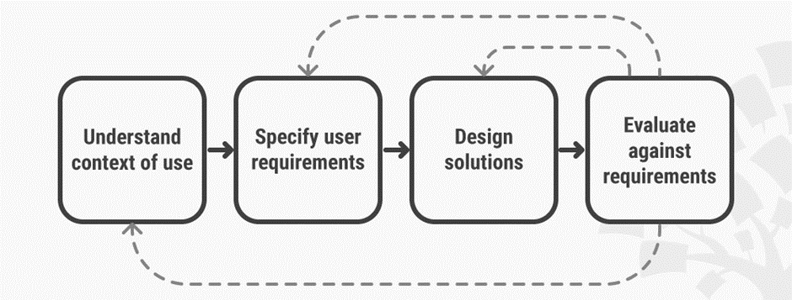
1️⃣ Understanding the User
- User kaun hai?
- Kya chahiye?
- Kis device par use karega?
🎯 Impact:
Website user ke real problems solve karti hai 👍

2️⃣ Ease of Use (Usability)
- Simple navigation
- Clear buttons
- Kam steps me kaam complete ho
🎯 Impact:
User confuse nahi hota, smoothly interact karta hai 😊

3️⃣ Accessibility
- Readable text
- Proper contrast
- Sab users ke liye usable (including disabled users)
🎯 Impact:
Website zyada inclusive aur trustworthy banti hai 🌍

4️⃣ Responsive & Performance-Focused
- Fast loading
- Mobile-friendly design
🎯 Impact:
User patience lose nahi karta ⏱️❌

5️⃣ Continuous Feedback & Improvement
- User feedback lena
- Design improve karte rehna
🎯 Impact:
Website time ke saath better hoti jaati hai 🔄✨

🚀 Why User-Centric Design Is Crucial for Successful Web Platforms
✅ Better User Experience
- User ko website use karna enjoyable lagta hai
✅ Higher Engagement
- Zyada clicks
- Zyada time spent
- Zyada interaction
✅ Lower Bounce Rate
- User turant website chhod ke nahi jaata
✅ Higher Conversions
- Signup, purchase, download ke chances badhte hain 🎯
✅ Brand Trust & Loyalty
- User wapas aana chahta hai 💙

❌ Without User-Centric Design
- Website confusing lagti hai
- Features unused rehte hain
- User alternatives dhoondh leta hai 😕

✍️ Exam-Oriented Conclusion (7 Marks Ready)
User-centric design focuses on designing websites according to user needs, preferences, and behavior. It emphasizes usability, accessibility, performance, and continuous improvement. This approach is crucial for creating successful web platforms as it enhances user satisfaction, engagement, trust, and overall effectiveness of the website.

Q10 : 10. Explain the significance of a sitemap in web design and development. How does planning and publishing a website involve the use of a sitemap?
Ans : 🔹 Sitemap kya hota hai?
Sitemap ek structured list / map hota hai jo website ke saare pages aur unke relationships ko show karta hai.
👉 Simple words me:
Sitemap website ka blueprint ya roadmap hota hai.
Isse pata chalta hai:
- Kaun-kaun se pages hain
- Kaunsa page kis se linked hai
- Website ka overall structure kya hai

🔑 Types of Sitemap
1️⃣ HTML Sitemap
- Users ke liye hota hai
- Website par ek page hota hai jisme saare links hote hain
👉 Helps in easy navigation

2️⃣ XML Sitemap
- Search engines ke liye hota hai
- Google, Bing ko batata hai kaun se pages important hain
👉 Helps in SEO & indexing

🌟 Significance (Importance) of Sitemap
1️⃣ Better Website Planning
- Development se pehle structure clear ho jaata hai
- Kaunsa page kaha hoga, sab decide hota hai
🎯 Benefit:
Confusion kam, development fast 🚀

2️⃣ Improved Navigation
- Pages logically connected hote hain
- User easily explore kar pata hai
🎯 Benefit:
User lost feel nahi karta 😊

3️⃣ SEO Improvement
- Search engines ko saare pages mil jaate hain
- New pages jaldi index hote hain
🎯 Benefit:
Website search results me better rank karti hai 📈

4️⃣ Easy Maintenance
- New pages add karna easy
- Broken links track karna simple
🎯 Benefit:
Website future-ready banti hai 🔄

🛠️ Role of Sitemap in Planning a Website
👉 Planning Phase me:
- Website ka skeleton banaya jaata hai
- Pages ka hierarchy decide hota hai
- Content placement plan hota hai
📌 Example:
Home
├── About
├── Services
│ ├── Web Design
│ └── Development
├── Contact

🚀 Role of Sitemap in Publishing a Website
👉 Publishing Phase me:
- XML sitemap search engines ko submit kiya jaata hai
- Crawlers easily website scan karte hain
- Pages efficiently index hote hain
🎯 Result:
- Better visibility
- Faster discovery of content

❌ Without Sitemap ke Problems
- Poor navigation
- Pages miss ho jaate hain
- SEO weak ho jaata hai
- User experience kharab hota hai 😕

✍️ Exam-Oriented Conclusion (7 Marks Ready)
A sitemap is a structured representation of a website that outlines its pages and their relationships. It plays a crucial role in web design and development by helping in proper planning, improving navigation, enhancing search engine indexing, and simplifying website maintenance. During planning, it acts as a blueprint, and during publishing, it helps search engines efficiently crawl and index the website.

UNIT -02

